1.Core Java Basics

What is Java?
Java is a class-based, object-oriented programming language that is designed to be secure and portable. Its core principle is “Write Once, Run Anywhere” (WORA), meaning Java code can run on any device or operating system that has a Java Virtual Machine (JVM).

History:
Java is a high-level, object-oriented programming language developed by Sun Microsystems in 1995. It is mostly used for building desktop applications, web applications, Android apps, and enterprise systems.

Key Features of Java
- Platform Independent: Java is famous for its Write Once, Run Anywhere (WORA) feature. This means we can write our Java code once, and it will run on any device or operating system if Java Virtual Machine is installed.
- Simple: No complex features like pointers and multiple inheritance, which makes it a good choice for beginners.
- Object-Oriented: This makes code clean and reusable.
- Secured: Since there are no pointers, it has built-in protections to keep our programs secure from common problems like memory leakage and segment fault.
- Multithreading: Programs can do many things at the same time using multiple threads. This is useful for handling complex tasks like processing transactions.
- Just-In-Time (JIT) Compiler: Java uses a JIT compiler. It improves performance by converting the bytecode into machine readable code at the time of execution.

Java Development Environment:
JDK (Java Development Kit):
A toolkit that allows you not only to run, but also to develop Java programs in environments such as IDEs.
Java Development Kit (JDK) is a cross-platformed software development environment that offers a collection of tools and libraries necessary for developing Java-based software applications and applets.
It is a core package used in Java, along with the JVM (Java Virtual Machine) and the JRE (Java Runtime Environment).
The JDK is a complete development kit that includes the JVM, JRE, and various development tools like the javac compiler (which converts Java files into bytecode).
It also contains tools for debugging and running Java code. In order to develop and execute Java programs, the JDK is necessary.
- Can you run Java code without JDK?
No, the JDK is required to compile and run Java programs.
- What happens if JRE and JDK versions are different?
JRE is part of the JDK, so they need to be compatible. A mismatch may lead to compatibility issues or compile-time errors.
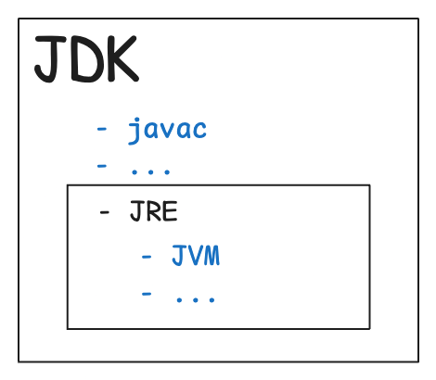
Tools of JDK
JDK contains:
- Java Runtime Environment (JRE),
- An interpreter/loader (Java),
- A compiler (javac),
- An archiver (jar) and many more.
The jar file is nothing but a full pack of Java classes
Component | Use
javac | Java compiler converts source code into Java bytecode
java | The loader of the java apps.
javap | Class file disassembler,
javadoc | Documentation generator,
jar | Java Archiver helps manage JAR files.
appletviewer | Debugging of Java applets without a web browser,
xjc | Accepts an XML schema and generates Java classes,
apt | Annotation-processing tool,
jdb | Debugger,
jmc | Java Mission Control,
JConsole | Monitoring and Management Console,
pack200 | JAR compression tool,
extcheck | Utility tool to detects JAR file conflicts,
idlj | IDL-to-Java compiler,
keytool | The keystore manipulating tool,
jstatd | jstat daemon (experimental)
jstat | JVM statistics monitoring tool
jshell | jshell introduced in java 9.
jstack | Prints Java stack traces(experimental)
jrunscript | Java command-line script shell.
jhat | Java Heap Analysis Tool (experimental)
jpackage | Generate self-contained application bundles.
javaws | Web Start launcher for JNLP applications,
javah | C header and stub generator,
jarsigner | jar signing and verification tool
jinfo | configuration information(experimental)

JRE (Java Runtime Environment):
JRE = JVM + Libraries + Other components needed to run Java applications.
JRE includes everything needed to only run pre-compiled Java applications.
The JRE loads classes check memory access and get system resources. JRE acts as a software layer on top of the operating system.
JRE is essentially the JVM plus the Java libraries that support the execution of Java programs.
It includes packages like java.lang, java.util, java.math, etc. With JRE, you can run Java applications but cannot develop them.
Components of Java JRE
The components of JRE are mentioned below:
- Integration libraries include Java Database Connectivity (JDBC)
- Java Naming, Interface Definition Language (IDL)
- Directory Interface (JNDI)
- Remote Method Invocation Over Internet Inter-Orb Protocol (RMI-IIOP)
- Remote Method Invocation (RMI)
- Scripting

Working of JRE
Java Development Kit (JDK) and Java Runtime Environment (JRE) both interact with each other to create a sustainable runtime environment that enables Java-based applications to run seamlessly on any operating system. The JRE runtime architecture consists of the following elements as listed:
- ClassLoader
- ByteCode verifier
- Interpreter

1.ClassLoader:
Java ClassLoader dynamically loads all the classes necessary to run a Java program. Because classes are only loaded into memory whenever they are needed, the JRE uses ClassLoader will automate this process when needed. During the initialization of the JVM, three classLoaders are loaded:
- Bootstrap class loader:
  - The Bootstrap ClassLoader is a machine code responsible for initiating the JVM's operations.
  - Bootstrap ClassLoader operates independently without any parent ClassLoaders.
- Extensions class loader:(Platform class loader)
  - It loads platform-specific extensions from the JDK's module system.
  - Platform Class Loader loads files from the Java runtime image or from any other module specified by the system property java.platform or --module-path.

- System class loader:
  - Also known as the Application ClassLoader, it loads classes from the application's classpath.
  - It is a child of the Platform Class Loader.
  - Classes are loaded from directories specified by the environment variable CLASSPATH, the -classpath or -cp command-line option.
2.ByteCode verifier:
The bytecode checker ensures the format and precision of Java code before passing it to the interpreter. If the code violates system integrity or access rights, the class is considered corrupt and will not load.
3.Interpreter:
After loading the byte code successfully, the Java interpreter creates an object of the JVM that allows the Java program to run natively on the underlying machine.

How does JRE work with JVM?
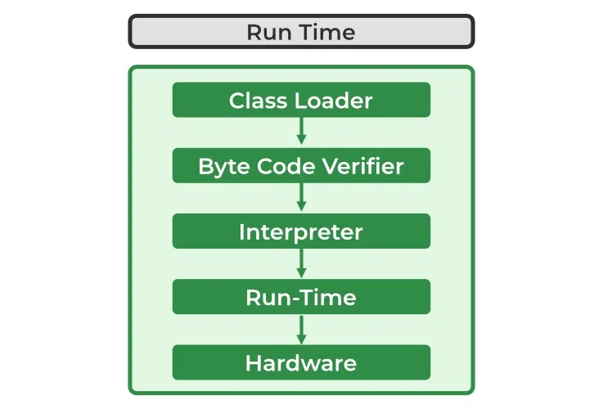
Difference between JVM, JRE, and JDK.
- JVM: JVM stands for Java Virtual Machine. JVM is used for running Java bytecode. Java applications are called WORA (Write Once Run Anywhere). This means a programmer can develop Java code on one system and can expect it to run on any other Java-enabled system without any adjustment. This is all possible because of JVM.
- JRE: JRE stands for Java Runtime Environment. JRE is made up of class libraries.
- JDK: JDK stands for Java Development Kit. JDK contains the JRE with compiler, interpreter, debugger, and other tools. It provides features to run as well as develop Java Programs.

JVM (Java Virtual Machine):
JVM is the engine that runs Java programs. It converts Java bytecode (compiled code) into machine code (understandable by the OS).
The virtual machine that translates the bytecode generated by the Java compiler into instructions that the operating system can understand and execute.
JVM is the core component among JDK, JVM, and JRE.
The Java Virtual Machine is a virtual environment where Java code is executed.
The JVM works following primary tasks:
- Loads code
- Verifies code
- Executes code
- Provides runtime environment

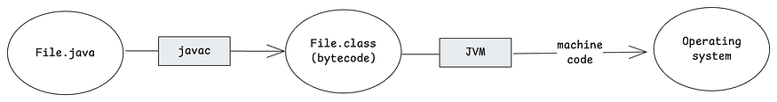

This process improves the JVM’s execution speed and works as follows:
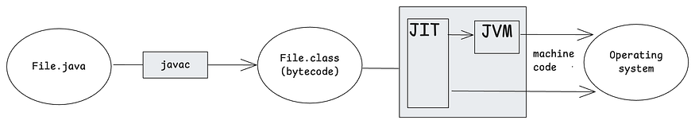

When we run a .java file, some parts of the code are called “hot code”. This refers to code that is executed repeatedly.
The JVM detects these frequently executed sections and compiles them at runtime to avoid interpreting them every time. This process is known as JIT (Just-In-Time compilation).
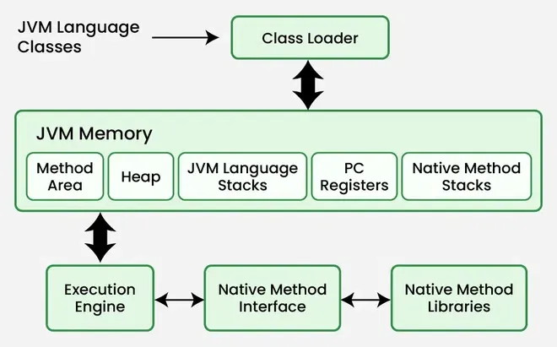

Core Components Of JVM:
1. Class Loader Subsystem
It is mainly responsible for three activities.
- Loading
- Linking
- Initialization
Loading: The Class loader reads the “.class” file, generate the corresponding binary data and save it in the method area. For each “.class” file, JVM stores the following information in the method area.
Linking: Performs verification, preparation, and (optionally) resolution.
  - Verification: It ensures the correctness of the .class file i.e. it checks whether this file is properly formatted and generated by a valid compiler or not.
  - Preparation: JVM allocates memory for class static variables and initializing the memory to default values.
  - Resolution: It is the process of replacing symbolic references from the type with direct references. It is done by searching into the method area to locate the referenced entity.
Initialization: In this phase, all static variables are assigned with their values defined in the code and static block(if any). This is executed from top to bottom in a class and from parent to child in the class hierarchy.
    - Bootstrap class loader: Every JVM implementation must have a bootstrap class loader, capable of loading trusted classes.
    - Extension class loader: It is a child of the bootstrap class loader. It loads the classes present in the extensions directories
    - System/Application class loader: It is a child of the extension class loader. It is responsible to load classes from the application classpath.
2. Class Loaders
There are three primary types of class loaders:
- Bootstrap Class Loader: Loads core Java API classes from the JAVA_HOME/lib directory. It is implemented in native code and is not a Java object.
- Extension Class Loader: Loads classes from the JAVA_HOME/jre/lib/ext directory or any directory specified by the java.ext.dirs system property. It is implemented in Java.
- System/Application Class Loader: Loads classes from the application classpath, which is specified by the java.class.path environment variable. It is also implemented in Java.
3. JVM Memory Areas
- Method area: In the method area, all class level information like class name, immediate parent class name, methods and variables information etc. are stored, including static variables.
- Heap area: Information of all objects is stored in the heap area.
- Stack area: For every thread, JVM creates one run-time stack which is stored here. Every block of this stack is called activation record/stack frame which stores methods calls. All local variables of that method are stored in their corresponding frame. After a thread terminates, its run-time stack will be destroyed by JVM.
- PC Registers: Store address of current execution instruction of a thread. Obviously, each thread has separate PC Registers.
- Native method stacks: For every thread, a separate native stack is created. It stores native method information.

4. Execution Engine
Execution engine executes the “.class” (bytecode).
- Interpreter: It interprets the bytecode line by line and then executes. The disadvantage here is that when one method is called multiple times, every time interpretation is required.
- Just-In-Time Compiler (JIT): It is used to increase the efficiency of an interpreter. It compiles the entire bytecode and changes it to native code so whenever the interpreter sees repeated method calls, JIT provides direct native code for that part so re-interpretation is not required, thus efficiency is improved.
- Garbage Collector: It destroys un-referenced objects.

5. Java Native Interface (JNI)
It is an interface that interacts with the Native Method Libraries and provides the native libraries(C, C++) required for the execution.

6. Native Method Libraries
These are collections of native libraries required for executing native methods. They include libraries written in languages like C and C++.

Garbage Collection:
Garbage collection in Java is an automatic memory management process that helps Java programs run efficiently.
- Objects are created on the heap area.
- Eventually, some objects will no longer be needed.
- Garbage collection is an automatic process that removes unused objects from heap.
Working of Garbage Collection
- It identifies which objects are still in use (referenced) and which are not in use (unreferenced).
- It removes the objects that are unreachable (no longer referenced).
- The programmer does not need to mark objects to be deleted explicitly. Garbage collection is implemented within the JVM.

Types of Activities in Java Garbage Collection:
Java heap is divided into generations:
- Young Generation: In this new objects are allocated.
- Old Generation: In this long-lived objects are stored.

Two types of garbage collection activities usually happen in Java. These are:
- Minor or incremental Garbage Collection (GC): This occurs when unreachable objects in the Young Generation heap memory are removed.
- Major or Full Garbage Collection (GC): This happens when objects that survived minor garbage collection are removed from the Old Generation heap memory. It occurs less frequently than minor garbage collection.

Types of Garbage Collectors:
1. Serial Garbage Collector
- Serial Garbage Collector is the simplest type of garbage collector.
- It uses a single thread to handle all garbage collection tasks.
- When garbage collection is triggered, it pauses all running application threads.
- Serial Garbage Collector is used for small applications or embedded systems where memory is limited.

2. Parallel Garbage Collector
- Parallel Garbage Collector is the default garbage collector in Java 8.
- It is also known as the throughput collector
- It uses multiple threads to perform garbage collection tasks.
- Parallel Garbage Collector is suitable for applications that need high performance and can tolerate some pauses, such as batch processing systems.

3. Concurrent Mark-Sweep Collector
- Concurrent Mark-Sweep Collector is designed to minimize pause times by doing most of its work while the application is still running.
- It uses multiple threads to mark and clean up unreachable objects.
- CMS Garbage collector will perform freezing of running threads i.e. application pause in two cases only:
  - While performing the garbage collection, If there is a change in heap memory in parallel.
  - While marking the referenced objects in the old generation space.
- Concurrent Mark-Sweep Collector is used for applications that require low latency, such as web servers and interactive applications.

4. G1 Garbage Collector
- Designed for applications with large heap sizes (greater than 4GB).
- Divides the heap into multiple equal-sized regions (1MB to 32MB).
- Marks regions with active objects and prioritizes collection in regions with the most unused objects, hence the name "Garbage-First" (G1).
- Compacts free heap space after garbage collection, improving memory efficiency.

5. Z Garbage Collector:
- ZGC is a low-latency garbage collector introduced in Java 11.
- It is designed to handle large heaps with minimal pause times, typically in the range of milliseconds.

6. Shenandoah Garbage Collector
- Shenandoah is another low-pause-time garbage collector introduced in Java 12.
- It aims to reduce pause times by performing garbage collection concurrently with application threads.

Data Types:
Data types specify the type of values a variable can hold. They define the size, range and nature of data stored in memory. Java has two main categories of data types:
- Primitive: byte, short, int, long, float, double, char, boolean
- Non-Primitive: String, Arrays, Classes, Interfaces, Objects
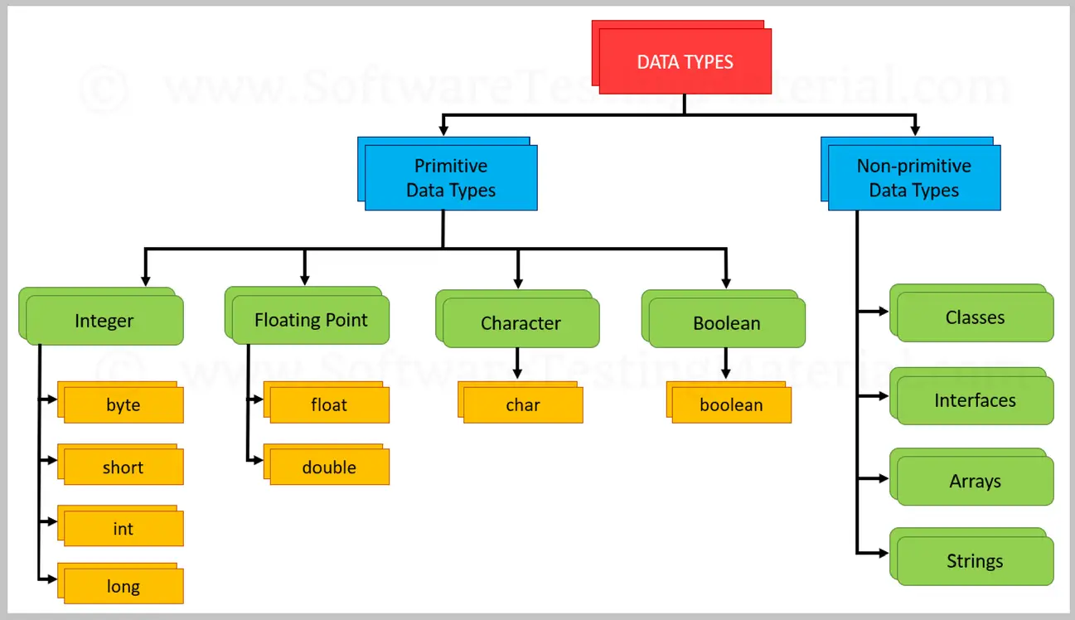

- Integer types stores whole numbers, positive or negative (such as 123 or -456), without decimals.
- Floating point types represents numbers with a fractional part, containing one or more decimals.
- Java has a boolean data type, which can only take the values true or false
- The char data type is used to store a single character.

- String: The string is a class in Java, and it represents the sequences of characters.
- Arrays: Arrays are created with the help of primitive data types and store multiple values of the same type.
- Classes: The classes are the user-defined data types and consist of variables and methods.
- Interfaces: The interfaces are abstract types that are used to specify a set of methods.

Variables:
Variables are containers to store data in memory. Each variable has a name, type and value. It is the basic unit of storage in a program. Java has 4 types of variables.
- Local Variables: Declared inside a method, constructor, or block. Accessible only within that block.
- Instance Variables: Declared inside a class but outside any method. Each object of the class has its own copy.
- Static Variables: Declared with the static keyword inside a class. Shared by all objects of the class.
- Final Variables: Declared with final keyword. Value cannot be changed once assigned.

Keywords:
Keywords are reserved words in Java that have a predefined meaning. They cannot be used as variable names, class names or identifiers.
Examples: new, package, private, protected, public, return, short, static, etc.

Operators in Java:
Operators are symbols that perform specific operations on one or more operands (variables or values). They are used to perform calculations, comparisons, logical operations and manipulate data.
They are basically of 7 types:
- Arithmetic Operators: +, -, *, /, %
- Relational Operators: ==, !=, >, <, >=, <=
- Logical Operators: &&, ||, !
- Assignment Operators: =, +=, -=, *=, /=, %=
- Unary Operators: +, -, ++, --, !
- Ternary Operator: condition ? value_if_true : value_if_false
- Bitwise Operators: &, |, ^, ~, <<, >>, >>>
Type Casting
Type casting is when you assign a value of one primitive data type to another type.
In Java, there are two types of casting:
Widening Casting (automatically) - converting a smaller type to a larger type size
byte -> short -> char -> int -> long -> float -> double
Narrowing Casting (manually) - converting a larger type to a smaller size type
double -> float -> long -> int -> char -> short -> byte

Decision Making (Control Statements) in Java:
Decision-making (or control statements) are used to execute different blocks of code based on certain conditions. They allow a Java program to choose a path of execution depending on whether a condition is true or false.
- if: Executes a block if a condition is true.
- if-else: Chooses between two blocks based on a condition.
- if-else if-else: Tests multiple conditions sequentially.
- switch: Selects one block from multiple options based on a variable’s value.

Loops
Loops are control statements in Java that allow a block of code to be executed repeatedly as long as a specified condition is true. They help in reducing code repetition.
There are 4 types of loops in Java.
- for: Used when the number of iterations is known.
- while: Used when the number of iterations is not known in advance, condition checked before each iteration.
- do-while: Similar to while loop, but condition is checked after executing the block (executes at least once).
- for-each: Used to iterate over arrays and collections.

Java Methods
Java Methods are blocks of code that perform a specific task. All methods in Java must belong to a class. Methods are similar to functions and expose the behavior of objects.
Method Call Stack in Java
When a method is called, Java uses an internal structure known as the call stack to manage execution, variables, and return addresses.
What is the Call Stack
The call stack is a data structure used by the program during runtime to manage method calls and local variables. It operates in a Last-In-First-Out (LIFO) manner, meaning the last method called is the first one to complete and exit.
How Are Methods Executed
When a method is called:
- A new stack frame is added to the call stack to store method details.
- The method runs its code.
- After execution, the stack frame is removed, and control goes back to the calling method.
Java automatically manages the call stack using the Java Virtual Machine (JVM).
Types of Methods in Java
1. Predefined Method
Predefined methods are the method that is already defined in the Java class libraries. It is also known as the standard library method or built-in method.
2. User-defined Method
The method written by the user or programmer is known as a user-defined method. These methods are modified according to the requirement.

Different Ways to Create Java Method
There are two ways to create a method in Java:
1.Instance Method: Access the instance data using the object name. Declared inside a class.
// Instance Method
void method_name() {
// instance method body
}
2. Static Method: Access the static data using class name. Declared inside class with static keyword.
// Static Method
static void method_name() {
// static method body
}
Method Signature
It consists of the method name and a parameter list.
- Number of parameters
- Type of the parameters
- Order of the parameters

Calling Different Types of Methods in Java
Method calling in Java means invoking a method to execute the code it contains. It transfers control to the process, runs its logic, and then returns to the calling point after execution.

1. Calling a User-Defined Method
User-defined methods are blocks of code written by the programmer. To execute a user-defined method, we first create an object of the class (if the method is non-static) and then call the method using that object
2. Calling an Abstract Method
Abstract methods have no body and must be overridden in a subclass. They are called using an object of the subclass.
3. Calling the Predefined Methods
Java provides many built-in methods via the Java Standard Library, like hashCode().
4. Calling a Static Method
Static methods belong to the class, not the object. They can be called without creating an object.

Access Modifiers
access modifiers are essential tools that define how the members of a class, like variables, methods, and even the class itself, can be accessed from other parts of our program.

Types of Access Modifiers
There are 4 types of access modifiers available in Java:
- Default - No keyword required
- Private
- Protected
- Public

Algorithm to Use Access Modifier in Java
Here's a basic algorithm for using access modifiers in Java:
1. Define a class: Create a class to represent the object you want to manage.
2. Define instance variables: Inside the class, define variables for the data you want to manage.
3. Set an access modifier:
- Use private for variables only accessible within the class.
- Use protected for variables accessible within the class and its subclasses.
- Use public for variables accessible from anywhere.
4. Use getter and setter methods: To access or modify variables, use getter (accessor) and setter (mutator) methods, even for public variables, to maintain encapsulation.

1. Default Access Modifier
When no access modifier is specified for a class, method, or data member, it is said to have the default access modifier by default. This means only classes within the same package can access it.
2. Private Access Modifier
The private access modifier is specified using the keyword private. The methods or data members declared as private are accessible only within the class in which they are declared.
3. Protected Access Modifier
The protected access modifier is specified using the keyword protected. The methods or data members declared as protected are accessible within the same package or subclasses in different packages.
4. Public Access Modifier
The public access modifier is specified using the keyword public.
- The public access modifier has the widest scope among all other access modifiers.
- Classes, methods, or data members that are declared as public are accessible from everywhere in the program. There is no restriction on the scope of public data members.

OOP’S

OOPs means Object-Oriented Programming System (or Object-Oriented Programming - OOP).
It is a programming paradigm (a way of designing and structuring code) that is based on the concept of objects.

Classes and Objects
A class is a template to create objects having similar properties and behavior, or in other words, we can say that a class is a blueprint for objects.
A class in Java is a template with the help of which we create real-world entities known as objects that share common characteristics and properties.
Properties of Java Classes
- A class itself does not occupy memory for its attributes and methods until an object is instantiated.
- A Class in Java can contain Data members, methods, a Constructor, Nested classes, and interfaces.
Components of Java Classes
In general, class declarations can include these components, in order:
- Modifiers: A class can be public or has default access
- Class keyword: Class keyword is used to create a class.
- Class name: The name should begin with an initial letter (capitalized by convention).
- Superclass (if any): The name of the class's parent (superclass), if any, preceded by the keyword extends. A class can only extend (subclass) one parent.
- Interfaces(if any): A comma-separated list of interfaces implemented by the class, if any, preceded by the keyword implements. A class can implement more than one interface.
- Body: The class body is surrounded by braces, { }.
- Fields: Fields are variables defined within a class that hold the data or state of an object.
- Constructors: It is a special method in a class that is automatically called when an object is created. And it's name is same as class name.

Java Objects

Objects are the instances of a class that are created to use the attributes and methods of a class. An object consists of:
- State: It is represented by attributes of an object. It also reflects the properties of an object.
- Behavior: It is represented by the methods of an object. It also reflects the response of an object with other objects.
- Identity: It gives a unique name to an object and enables one object to interact with other objects.

Ways to Create an Object of a Class
1. Using new Keyword
It is the most common and general way to create an object in Java.
2. Using Reflection (Dynamic Class Loading)
Reflection is a powerful feature in Java that allows a program to inspect and modify its own structure and behavior at runtime.
3. Using clone() method
The clone() method is present in the Object class. It creates and returns a copy of the object.
4. Deserialization
De-serialization is a technique of reading an object from the saved state in a file.

Anonymous Objects
Anonymous objects are objects that are instantiated without storing their reference in a variable. They are used for one-time operations (e.g., method calls) and are discarded immediately after use.

Inheritance
It is the mechanism in Java by which one class is allowed to inherit the features(fields and methods) of another class. In Java, Inheritance means creating new classes based on existing ones.

Why Use Inheritance in Java?
- Code Reusability: The code written in the Superclass is common to all subclasses. Child classes can directly use the parent class code.
- Method Overriding: Method Overriding is achievable only through Inheritance. It is one of the ways by which Java achieves Run Time Polymorphism.
- Abstraction: The concept of abstraction where we do not have to provide all details, is achieved through inheritance. Abstraction only shows the functionality to the user.

How Inheritance Works in Java?
The extends keyword is used for inheritance in Java. It enables the subclass to inherit the fields and methods of the superclass. When a class extends another class, it means it inherits all the non-primitive members (fields and methods) of the parent class and the subclass can also override or add new functionality to them.

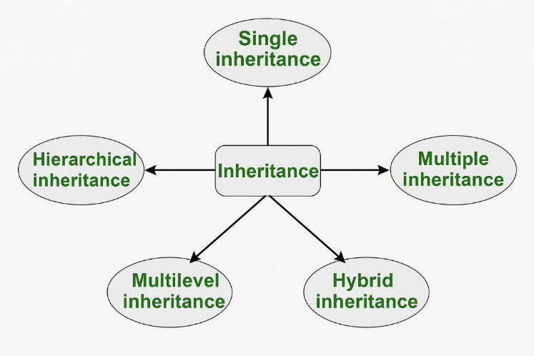

1. Single Inheritance
In single inheritance, a sub-class is derived from only one super class. It inherits the properties and behavior of a single-parent class.
2. Multilevel Inheritance
In Multilevel Inheritance, a derived class will be inheriting a base class and as well as the derived class also acts as the base class for other classes.
3. Hierarchical Inheritance
In hierarchical inheritance, more than one subclass is inherited from a single base class. i.e. more than one derived class is created from a single base class.
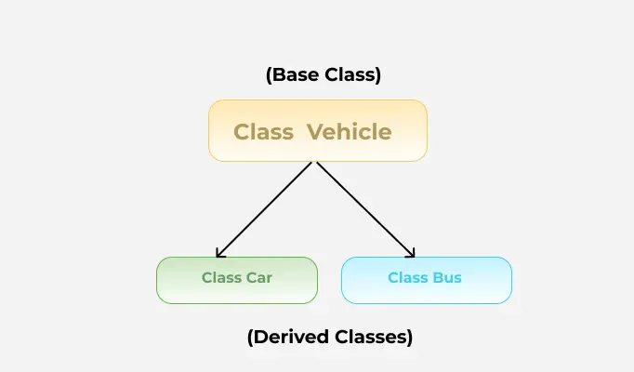
4. Multiple Inheritance (Through Interfaces)
In Multiple inheritances, one class can have more than one superclass and inherit features from all parent classes.
Note: that Java does not support multiple inheritances with classes. In Java, we can achieve multiple inheritances only through Interfaces.
5. Hybrid Inheritance
It is a mix of two or more of the above types of inheritance. In Java, we can achieve hybrid inheritance only through Interfaces if we want to involve multiple inheritance to implement Hybrid inheritance.

Polymorphism
that allows objects to behave differently based on their specific class type. The word polymorphism means having many forms, and it comes from the Greek words poly (many) and morph (forms), this means one entity can take many forms. In Java, polymorphism allows the same method or object to behave differently based on the context, specially on the project's actual runtime class.
Key features of polymorphism:
- Multiple Behaviors: The same method can behave differently depending on the object that calls this method.
- Method Overriding: A child class can redefine a method of its parent class.
- Method Overloading: We can define multiple methods with the same name but different parameters.
- Runtime Decision: At runtime, Java determines which method to call depending on the object's actual class.
Types of Polymorphism in Java
In Java Polymorphism is mainly divided into two types:
- Compile-Time Polymorphism (Static)
Compile-Time Polymorphism in Java is also known as static polymorphism and also known as method overloading. This happens when multiple methods in the same class have the same name but different parameters.
Method overloading in Java means when there are multiple functions with the same name but different parameters then these functions are said to be overloaded. Functions can be overloaded by changes in the number of arguments or/and a change in the type of arguments.
- Runtime Polymorphism (Dynamic)
Runtime Polymorphism in Java known as Dynamic Method Dispatch. It is a process in which a function call to the overridden method is resolved at Runtime. This type of polymorphism is achieved by Method Overriding. Method overriding, on the other hand, occurs when a derived class has a definition for one of the member functions of the base class. That base function is said to be overridden.
Method overriding in Java means when a subclass provides a specific implementation of a method that is already defined in its superclass. The method in the subclass must have the same name, return type, and parameters as the method in the superclass.

Abstraction
Abstraction in Java is the process of hiding internal implementation details and showing only essential functionality to the user
Key features of abstraction
- Abstraction hides the complex details and shows only essential features.
- Abstract classes may have methods without implementation and must be implemented by subclasses.
- By abstracting functionality, changes in the implementation do not affect the code that depends on the abstraction.

Abstract class
An abstract class is a way to achieve abstraction in Java. It is declared using the abstract keyword and can contain both abstract methods non abstract methods. Abstract classes cannot be instantiated directly and are meant to be extended by subclasses.

Interface
Interfaces is a blueprint of a class used to achieve 100% abstraction in Java. It can contain abstract methods and constants but no method bodies (except default and static methods from Java 8 onward).
Implementation: To implement an interface we use the keyword “implements” with class.

Encapsulation
encapsulation is one of the core concepts of Object Oriented Programming (OOP) in which we bind the data members and methods into a single unit. Encapsulation is used to hide the implementation part and show the functionality for better readability and usability.
- Simpler Parameter Passing: When we pass an object to a method, everything (associated data members and methods are passed along). We do not have to pass individual members.
- getter and setter: getter (display the data) and setter method ( modify the data) are used to provide the functionality to access and modify the data, and the implementation of this method is hidden from the user. The user can use this method, but cannot access the data directly.

Stack vs Heap Memory Allocation
Java, memory can be allocated on either a stack or a heap. Stack allocation happens in the function call stack, where each function gets its own memory for variables. In C/C++, heap memory is controlled by programmer as there is no automatic garbage collection.

Stack Allocation
Stack allocation refers to the process of assigning memory for local variables and function calls in the call stack. It happens automatically when a function is called and is freed immediately when the function ends.
If too many function calls exceed the stack's capacity, it results in a stack overflow error.

How Stack Allocation Works
- Memory is allocated in contiguous blocks within the call stack.
- The size of memory required is already known before execution.
- When a function is called, its local variables are allocated on the stack.
- Once the function finishes execution, the allocated memory is automatically freed.
- The programmer does not need to handle allocation or deallocation.
- Since stack memory is freed when a function completes, it is also called temporary memory allocation.

Heap Allocation
Heap memory is allocated dynamically during program execution. Unlike stack memory, heap memory is not freed automatically when a function ends. Instead, it requires manual deallocation (In C/C++) or a garbage collector (in Java or Python) to reclaim unused memory.
Whenever an object is created, it is stored in heap memory, while references to these objects are stored in stack memory.

Categories of Heap Memory
Heap memory is divided into three categories, helping prioritize object storage and garbage collection:
- Young Generation – Stores new objects. When this space is full, unused objects are removed by the garbage collector, and surviving objects move to the Old Generation.
- Old (Tenured) Generation – Holds older objects that are no longer frequently used. These objects stay in memory unless explicitly removed.
- Permanent Generation (PermGen) – Stores JVM metadata, such as runtime classes and application methods.

Key Features of Heap Allocation
- If heap memory is full, JVM throws an error: java.lang.OutOfMemoryError.
- Unlike stack memory, automatic deallocation does not happen; a garbage collector is needed to free unused memory.
- Slower than stack memory due to manual allocation and garbage collection.
- Less thread-safe, as heap memory is shared among all threads.
- Typically larger in size compared to stack memory.
- Heap memory persists as long as the entire application is running.

Feature | Stack Memory | Heap Memory
Storage | Method calls, local variables | Objects, instance variables
Access | Only thread that owns it | Shared among all threads
Speed | Very fast | Slower
Management | Auto (method end clears it) | Garbage Collector manages it
Errors | StackOverflowError | OutOfMemoryError
Lifetime | Exists till method execution | Exists until no references + GC cleans it

Wrapper Classes
A Wrapper class in Java is one whose object wraps or contains primitive data types. When we create an object in a wrapper class, it contains a field and in this field, we can store primitive data types. In other words, we can wrap a primitive value into a wrapper class object.
A wrapper class is a class that converts a primitive data type into an object.

Autoboxing and Unboxing
1. Autoboxing
The automatic conversion of primitive types to the object of their corresponding wrapper classes is known as autoboxing. For example – conversion of int to Integer, long to Long, double to Double, etc.
2. Unboxing
It is just the reverse process of autoboxing. Automatically converting an object of a wrapper class to its corresponding primitive type is known as unboxing. For example, conversion of Integer to int, Long to long, Double to double, etc.
Custom Wrapper Classes in Java
Java Wrapper classes wrap the primitive data types. We can create a class that wraps data inside it. So let us check how to create our own custom wrapper class in Java. It can be implemented for creating certain structures like queues, stacks, etc.
Java Strings
a String is the type of object that can store a sequence of characters enclosed by double quotes and every character is stored in 16 bits, i.e., using UTF 16-bit encoding. A string acts the same as an array of characters. Java provides a robust and flexible API for handling strings, allowing for various operations such as concatenation, comparison and manipulation.
Ways of Creating a Java String
There are two ways to create a string in Java:
- String Literal
- Using new Keyword
1. String literal (Static Memory)
To make Java more memory efficient (because no new objects are created if it exists already in the string constant pool).
Example:
String str = “GeeksforGeeks”;
2. Using new keyword (Heap Memory)
- String s = new String("Welcome");
- In such a case, JVM will create a new string object in normal (non-pool) heap memory and the literal "Welcome" will be placed in the string constant pool. The variable s will refer to the object in the heap (non-pool)

Interfaces and Classes in Strings in Java

CharSequence Interface
CharSequence Interface is used for representing the sequence of Characters in Java. Classes that are implemented using the CharSequence interface are mentioned below and It provides basic methods such as length(), charAt(), subSequence() and toString().
1. String
String is an immutable class in Java, which means that once a String object is created, its value cannot be changed. If you want to modify a string a new String object is created and the original remains unchanged.
Syntax:
// Method 1
String str= "geeks";
// Method 2
String str= new String("geeks");
2. StringBuffer
StringBuffer is a peer class of String, it is mutable in nature and it is thread safe class , we can use it when we have multi threaded environment and shared object of string buffer i.e, used by mutiple thread. As it is thread safe so there is extra overhead, so it is mainly used for multithreaded program.
Unlike String (which is immutable), you can modify a StringBuffer object without creating a new one.
It is synchronized (thread-safe) → safe to use in multi-threaded environments.
Syntax:
StringBuffer demoString = new StringBuffer("GeeksforGeeks");
Common Methods
Method | Description
append(str) | Adds text at the end
insert(index, str) | Inserts text at given position
replace(start, end, str) | Replaces part of string
delete(start, end) | Deletes part of string
reverse() | Reverses the string
capacity() | Shows storage capacity
length() | Returns length of content
ensureCapacity(int) | Increases buffer capacity

3. StringBuilder
StringBuilder in Java represents an alternative to String and StringBuffer Class, as it creates a mutable sequence of characters and it is not thread safe. It is used only within the thread , so there is no extra overhead , so it is mainly used for single threaded program.
Syntax:
StringBuilder demoString = new StringBuilder();
demoString.append("GFG");
StringBuilder is similar to StringBuffer.
It is a mutable sequence of characters (we can modify it without creating a new object).
Not synchronized → not thread-safe, but faster than StringBuffer.

Uses:
Use StringBuilder in most cases when string manipulation is frequent.
Use StringBuffer only when multiple threads modify the same string.
4. StringTokenizer
StringTokenizer class in Java is A StringTokenizer object internally maintains a current position within the string to be tokenized. Some operations advance this current position past the characters processed. A token is returned by taking a substring of the string that was used to create the StringTokenizer object.used to break a string into tokens.
Syntax:
public StringJoiner(CharSequence delimiter)

Immutable String in Java
In Java, string objects are immutable. Immutable simply means unmodifiable or unchangeable. Once a string object is created its data or state can't be changed but a new string object is created.
How Strings are Stored in Java Memory
String literal
Whenever a String Object is created as a literal, the object will be created in the String constant pool. This allows JVM to optimize the initialization of String literal. The string constant pool is present in the heap.
Example 1: Using String literals to assigning char sequence value.
String str1 = "Hello";
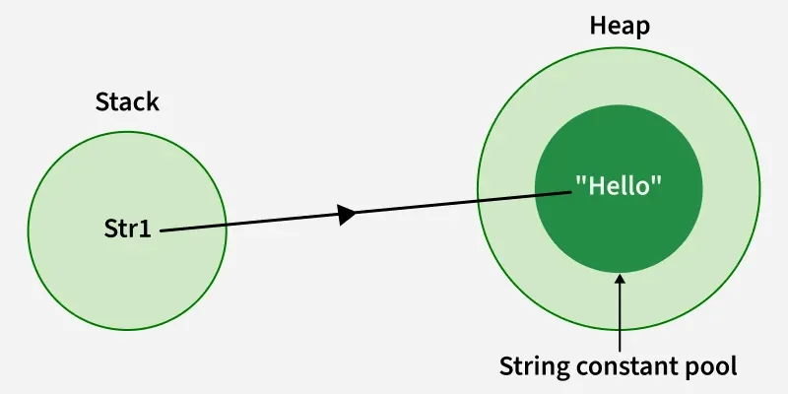

Collections:
A collection in Java is a group of individual objects that are treated as a single unit. In Java, a separate framework named the "Collection Framework" was defined in JDK 1.2, which contains all the Java Collection Classes and interfaces.

Hierarchy of the Collection Framework in Java
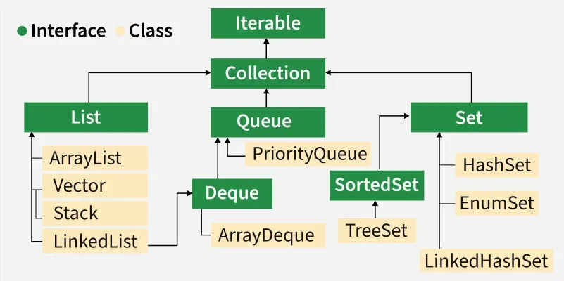
Interfaces that Extend the Java Collections Interface
The collection framework contains multiple interfaces where every interface is used to store a specific type of data.
1. Iterable Interface
Iterable interface is the root of the Collection Framework. It is extended by the Collection interface, making all collections inherently iterable. Its primary purpose is to provide an Iterator to traverse elements, defined by its single abstract method iterator().
Iterator iterator();
2. Collection Interface
Collection interface extends Iterable and serves as the foundation of the Collection Framework. It defines common methods like add(), remove(), and clear(), ensuring consistency and reusability across all collection implementations.
3. List Interface
List interface extends the Collection interface and represents an ordered collection that allows duplicate elements. It is implemented by classes like ArrayList, Vector, and Stack
The classes which implement the List interface are as follows:
ArrayList
ArrayList provides a dynamic array in Java that resizes automatically as elements are added or removed. Although slower than standard arrays, it is efficient for frequent modifications. It supports random access but cannot store primitive types directly—wrapper classes like Integer or Character are required
LinkedList:
LinkedList is a linear data structure where elements (nodes) are stored non-contiguously. Each node contains data and a reference to the next (and optionally previous) node, forming a chain of elements linked by pointers.
Vector:
Vector provides a dynamic array in Java, similar to ArrayList, but with synchronized methods for thread safety. While slower due to synchronization overhead, it is useful in multi-threaded environments. Like ArrayList, it resizes automatically during element manipulation.
Stack
Stack class implements the LIFO (last-in-first-out) data structure. It supports core operations like push() and pop(), along with peek(), empty(), and search(). Stack is a subclass of Vector and inherits its properties.
4. Queue Interface
The Queue interface follows the FIFO (First-In, First-Out) principle, where elements are processed in the order they are added—similar to a real-world queue (e.g., ticket booking).
The most frequently used implementation of the queue interface is the PriorityQueue.
Priority Queue
PriorityQueue processes elements based on their priority rather than insertion order. It uses a priority heap for internal storage. Elements are ordered either by their natural ordering or by a custom Comparator provided at construction.
5. Deque Interface
Deque interface extends Queue and allows insertion and removal of elements from both ends. It is implemented by classes like ArrayDeque, which can be used to instantiate a Deque object.
The class which implements the deque interface is ArrayDeque.
ArrayDeque
ArrayDeque class implements a resizable, double-ended queue that allows insertion and removal from both ends. It has no capacity restrictions and grows automatically as needed.
6. Set Interface
Set interface represents an unordered collection that stores only unique elements (no duplicates). It's implemented by classes like HashSet, TreeSet, and LinkedHashSet, and can be instantiated using any of these
The following are the classes that implement the Set interface:
HashSet
HashSet class implements a hash table and stores elements based on their hash codes. It does not guarantee insertion order and allows one null element.
LinkedHashSet
LinkedHashSet is very similar to a HashSet. The difference is that this uses a doubly linked list to store the data and retains the ordering of the elements.
7. Sorted Set Interface
Sorted Set interface extends Set and maintains elements in sorted order. It includes additional methods for range views and ordering. It is implemented by the TreeSet class.
The class which implements the sorted set interface is TreeSet.

TreeSet
TreeSet uses a self-balancing tree (Red-Black Tree) to store elements in sorted order. It maintains natural ordering or uses a custom Comparator if provided during creation. Ordering must be consistent with equals to ensure proper Set behavior.
Map Interface
Map is a data structure that supports the key-value pair for mapping the data. This interface doesn't support duplicate keys because the same key cannot have multiple mappings, however, it allows duplicate values in different keys
The frequently used implementation of a Map interface is a HashMap.
HashMap
HashMap is a basic implementation of the Map interface that stores data as key-value pairs. It uses hashing for fast access, converting keys into hash codes to index values efficiently.

Comparable vs Comparator
In Java, both Comparable and Comparator interfaces are used for sorting objects. The main difference between Comparable and Comparator is:
- Comparable: It is used to define the natural ordering of the objects within the class.
- Comparator: It is used to define custom sorting logic externally.
Features | Comparable | Comparator
Definition | It defines natural ordering within the class. | It defines external or custom sorting logic.
Method | compareTo() | compare()
Implementation | It is implemented in the class. | It is implemented in a separate class.
Sorting Criteria | Natural order sorting | Custom order sorting
Usage | It is used for a single sorting order. | It is used for multiple sorting orders.

Why comparator is a functional interface?
- Functional Interface were introduced in Java 8. It has exactly one abstract method.
- In Comparator<T>, the only abstract method is: int compare(T o1, T o2);
- The equals(Object obj) method in Comparator comes from the Object class, so it is not abstract in the interface.
- Therefore, Comparator qualifies as a functional interface and can be used with lambdas in Java 8+.

What is Core Java?
Java is a programming language that is class-based and object-oriented. It is designed to be general-purpose and aims to have fewer implementation dependencies, and serves as a computing platform for application development.

2. What IOC container does?
The IoC Container is responsible for creating objects, injecting dependencies, and managing the entire lifecycle of these objects. This process, known as Dependency Injection (DI), decouples the application's components, allowing for more flexible and maintainable code.
2. Inversion of Control (IOC) Container
Inversion of Control (IoC) is a design principle used in object-oriented programming where the control of object creation and dependency management is transferred from the application code to an external framework or container.

BeanFactory: BeanFactory is the simplest container and is used to create and manage beans. It is a basic container that initializes beans lazily (i.e., only when they are needed). It is typically used for lightweight applications where the overhead of ApplicationContext is not required.

